**GRAPHIC DESIGN PORTFOLIO**

**MINI PROJECT - II**

***Submitted by***

**PRAVEEN N**

**Roll No:727621MCA061**

### In partial fulfillment of the requirement for the award of the degree

### Of

**MASTER OF COMPUTER APPLICATIONS**

**Dr. MAHALINGAM COLLEGE OF ENGINEERING AND TECHNOLOGY POLLACHI - 642 003**

**(Approved by AICTE, Affiliated to Anna University and Accredited by NBA & NAAC with “A++” Grade)**

**AUGUST - 2022**

**Dr. MAHALINGAM COLLEGE OF ENGINEERING AND TECHNOLOGY POLLACHI – 642 003**

**Department of Computer Applications (MCA) MINI PROJECT - II REPORT**

**AUGUST 2022**

This is to certify that the project entitled

**GRAPHIC DESIGN PORTFOLIO**

The bonafide record of project work was done by

**PRAVEEN N**

**Roll No:727621MCA061**

Of Master of Computer Applications during the year 2021-2022

Project Guide Head of the Department

**Mrs. G.DEEPA, M.E. Dr. R. MUTHUSAMI, M.C.A., M.Phil., Ph.D.**

**Assistant Professor/MCA Head &Assistant Professor (SG)/MCA**

Submitted for the Project Viva-Voce examination held on

|  |  |  |
| --- | --- | --- |
| Internal Examiner |  | External Examiner |

**DECLARATION**

I affirm that the major project work titled “GRAPHIC DESIGN PORTFOLIO” being submitted in partial fulfillment for the award of Master of Computer Applications is the original work carried out by me. It has not formed the part of any other project work submitted for award of any degree or diploma,either in this or any other University.

(Signature of the Candidate)

**PRAVEEN.N**

**Roll No:727621MCA061**

I certify that the declaration made above by the candidate is true.

(Signature of the Guide)

**Mrs.G.Deepa,M.E.,**

**Assistant Professor/MCA**

ACKNOWLEDGEMENT

I express my gratitude to **Dr. C. RAMASWAMY, M.E., F.I.V., Secretary,** NIA Educational Institutions, Pollachi, for having provided me the facilities to do the project successfully.

I express my sincere thanks to **Dr. A. RATHINAVELU, B.E., M.Tech., Ph.D. ., Principal,** Dr. Mahalingam college of Engineering and Technology, Pollachi, for having provided me the facilities to do the project successfully.

I owe deep sense of gratitude to **Dr. R. MUTHUSAMI, M.C.A., M.Phil., Ph.D., Head** of Department of Computer Applications for appreciating my goal. I express my sincere thanks to his for his constant encouragement.

I express my thanks to my guide **Mrs. G.DEEPA, M.E.,** Assistant Professor, Department of Computer Applications for his/her valuable guidance and support to meet the successful completion of my project.

I express my sincere thanks to **all staff members of Department of Computer Applications** for their encouragement and valuable guidance throughout this project.

Last but not the least, I would like to thank **my family** and **my friends** for putting up with me spending so much time providing encouragement and valuable suggestions, throughout the project tenure.

**ABSTRACT**

This project based on web page is a sort of "Graphic Design Portfolio". A graphic design portfolio is a well curated presentation of work to the world. This web page contains some common features that can be found in some popular portfolio sites , which are the show my works, freelance work, course, live events, Tracking Results, etc. User can buy my products and sale , and learning graphic design courses. Admin can post their works in that page, sale of our products and manage activity.

**TABLE OF CONTENTS**

|  |  |  |
| --- | --- | --- |
| **CHAPTER.NO** | **TITLE** | **PAGE.NO** |
|  | **ABSTRACT** | **v** |
|  | **LIST OF FIGURES** | **viii** |
|  | **LIST OF TABLES** | **ix** |
|  | **LISTOF ABBREVIATION** | **x** |
| **1** | **INTRODUCTION** | **1** |
| 1.1 | Objective of the project | 1 |
| **2** | **SYSTEM ANALYSIS** | **2** |
| 2.1 | Existing System | 2 |
| 2.2 | Proposed system | 2 |
| 2.3 | Requirement Gathering | 2 |
| 2.4 | Feasibility Study | 3 |
| 2.4.1 | Economical Feasibility | 3 |
| 2.4.2 | Operational Feasibility | 3 |
| 2.4.3 | Technical Feasibility | 4 |
| **3** | **SYSTEM SPECIFICATION** | **5** |
| 3.1 | Hardware Specification | 5 |
| 3.2 | Software Specification | 5 |
| **4** | **SOFTWARE DESCRIPTION** | **6** |
| 4.1 | Programming languages | 6 |
| 4.2 | Development tools and Technologies | 7 |
| **5** | **PROJECT DESCRIPTION** | **9** |
| 5.1 | Problem Definition | 9 |
| 5.2 | Overview of the project | 9 |
| 5.3 | Module Description | 9 |
| 5.4 | System Design | 11 |
| 5.4.1 | Data Flow Diagram | 11 |
| 5.4.2 | System Flow Diagram | 12 |
| 5.4.3 | Use Case Diagram | 12 |
| 5.4.4 | Entity Relationship Diagram | 13 |
| 5.5 | Data base design | 14 |

|  |  |  |
| --- | --- | --- |
| **6** | **SYSTEM TESTING** | **15** |
| 6.1 | Testing Methodologies | 15 |
| 6.1.1 | Unit Testing | 15 |
| 6.1.2 | Integration Testing | 15 |
| 6.1.3 | Validation Testing | 16 |
| 6.2 | Test case | 16 |
| **7** | **SYSTEM IMPLEMENTATION** | **17** |
| 7.1 | Implementation of the system | 17 |
| **8** | **APPENDICES** | **19** |
| 8.1 | Source code | 19 |
| 8.2 | Screen shots | 46 |
| **9** | **CONCLUSION AND FUTURE ENHANCEMENTS** | **50** |
| 9.1 | Conclusion | 50 |
| 9.2 | Future Enhancement | 50 |
| **10** | **REFERENCES** | **51** |

**LIST OF FIGURES**

**FIG.NO DESCRIPTION PAGE.NO**

5.4.1 DATA FLOW DIAGRAM 10

5.4.2 SYSTEM FLOW DIAGRAM 11

5.4.3 USE CASE DIAGRAM 12

5.4.4 ENTITY RELATIONSHIP 13

DIAGRAM

**LIST OF TABLES**

**FIG.NO DESCRIPTION PAGE.NO**

5.5.1 Admin 14

5.5.2 User 14

**LIST OF ABBREVIATIONS**

**ABBREVIATION DEFINITION**

CSS Cascading Style Sheet

DFD Data Flow Diagram

ER Entity Relationship

GUI Graphical User Interface

HTML Hypertext Markup Language

**CHAPTER 1**

**INTRODUCTION**

1.1 **OBJECTIVE OF PROJECTS**

A graphic design portfolio is the visual representation of all you have accomplished so far and symbolizes what you hope to achieve in the future.Graphic designers need a portfolio to showcase their work in order to gain potential clients or jobs. My portfolio is an opportunity to share my design experience and give potential leads an idea of what my design style is like, graphic design,poster,etc.

**CHAPTER 2**

**2.1 EXISTING SYSTEM**

In all work done manually, the processing of all the users details of who has saw the task, who all registered was not an easy to perform manually.

**DRAWBACKS OF EXISTING SYSTEM**

* Registrations are sometimes blocked,
* Security issues,
* Photos sometimes blocked.

**2.2 PROPOSED SYSTEM**

This reduces the workload of the user and it is also a easy to buy products in one website.Graphic design portfolio management is typically carried out by portfolio managers.The key focus of GDP is to make sure that all the outcomes in the portfolio support the strategic goals and business objectives of the organization.The system maintains all records easy. The proposed system consists of different packages in terms of cost range for each category of activity.

**Benefits of the proposed system**

* Gain Visibility,
* Productivity,
* Greater efficiency,
* Better service,
* User and friendliness interactive..

**2.3 REQUIREMENT GATHERING**

We are overcoming the difficulty of portfolio which were overall in the current system and here we create one website for buying photos and sell in one website.

**2.3.1 NON-FUNCTIONAL REQUIREMENT**

An admin should be able to login to the system through the first page of the application and importing the he created images in the dashboard.

**2.3.2 NON-FUNCTIONAL REQUIREMENT**

* This section includes all of those requirements that effect usability.
* Web pages are loaded within seconds,
* The details need to be maintained properly,
* The details of user must be safe,
* The database must be kept backed up.

**2.4 FEASIBILITY STUDY**

Feasibility study is the test of analyzing the information of previous data and also needs and effective use of resources. The feasibility study is to serve as a decision document.

**2.4.1 ECONOMICAL FEASIBILITY**

Economic analysis is most frequently used for evaluation of the effectiveness of the system. More commonly known as cost/benefit analysis the procedure is to determine the benefit and saving that are expected from a system and compare them with costs, decisions is made to design and implement the system. It is economically feasible, it will only require a single operator to operate the system, who is responsible for entering the data into the database via a user interface provided to him, who can also able to show all the data in html tabular form.

**2.4.2 OPERATIONAL FEASIBILITY**

It is Operational feasible, since the system is providing an attractive user interface to the operator/end user, so user feels very easy to work onto it. Response to operator/end user is very fast and very good. Since, as we mentioned above that it requires much less amount of cost, it uses computer work so it is very fast to operate and it is very easy for user to work on it.

**2.4.3 TECHNICAL FEASIBILITY**

Technical feasibility centre on the existing manual system of the test management process and to what extent it can support the system. According to feasibility analysis procedure the technical feasibility of the system is analyzed and the technical requirement such as software facilities procedure, inputs is identified. It is also one of the important phases of the system development activities. It is technically feasible, since the whole system is designed into the latest technologies like Server which are the most recent technologies to develop web based systems and design databases. The system offers greater levels of user friendliness combined with greater processing speed. Therefore, the cost of maintenance can be reduced.

**CHAPTER 3**

**SYSTEM SPECIFICATION**

3.1 HARDWARE REQUIREMENTS

* + - Processor : Intel i3 or any equivalent processor
    - Memory : 4GB RAM
    - Processor speed : 2.00 GHz
    - Hard Disk : 40GB

3.2 SOFTWARE REQUIREMENTS

* + - Operating System : Windows 7/8/10
    - Front End : PYTHON
    - Database : My SQL
    - Web Server : XAMPP 10.4.21
    - Designing : HTML, CSS, Bootstrap
    - Validation : JavaScript

**CHAPTER 4**

**SOFTWARE DESCRIPTION**

**PROGRAMMING LANGUAGES:**

**HTML:**

Hypertext Markup Language (HTML) is the standard mark-up language for creating web pages and web applications. Web browsers receive HTML documents from a web server or from local storage and render them into multimedia web pages.

HTML describes the structure of a web page semantically and originally included cues for the appearance of the document. Web browsers receive HTML documents from a web server or from local storage and render them into multimedia web pages. HTML describes the structure of a web page semantically and originally included cues for the appearance of the document.

**CSS:**

Cascading Style Sheets (CSS) is a style sheet language used for describing the presentation of a document written in a mark-up language. Although most often used to set the visual style of web pages and user interfaces written in HTML and XHTML, the language can be applied to any XML document, including plain XML, SVG and XUL, and is applicable to rendering in speech, or on other media.

Along with HTML and JavaScript, CSS is a cornerstone technology used by most websites to create visually engaging web pages, user interfaces for web applications, and user interfaces for many mobile applications.

CSS is designed primarily to enable the separation of presentation and content, including aspects such as the layout, colors, and fonts. This separation can improve content accessibility, provide more flexibility and control in the specification of presentation characteristics, enable multiple HTML pages to share formatting by specifying the relevant CSS in a separate .CSS file, and reduce complexity and repetition in the structural content.

**PYTHON:**

Python is commonly used for developing websites and software, task automation, data analysis, and data visualization. Since it’s relatively easy to learn, Python has been adopted by many non-programmers such as accountants and scientists, for a variety of everyday tasks, like organizing finances. Easy to use, short code, flexible, and it is open source.

**MySQL:**

MySQL, the most popular Open Source SQL database management system, is developed, distributed, and supported by Oracle Corporation.

A database is a structured collection of data. It may be anything from a simple shopping list to a picture gallery or the vast amounts of information in a corporate network. To add, access, and process data stored in a computer database, you need a database management system such as MySQL Server. Since computers are very good at handling large amounts of data, database management systems play a central role in computing, as standalone utilities, or as parts of other applications.

here some key benefits that help explain why it is still important so important in web development.

* Data Security
* On demand scalability
* High performance
* Complete workflow control
* Comprehensive Transitional Support

**JAVASCRIPT:**

JavaScript is used to develop interactive web applications. JavaScript can power featured like interactive images, carousels, and forms. The language can be used with back-end frameworks like Node. js to power the mechanics behind a web page, such as form processing and payments.

Here are a few examples of the front end changes you can make to a website using JavaScript:

* Display information when a button is clicked
* Create a drop down menu that activates when clicked
* Allow a user to zoom in or out on an image
* Show a series of tabs on a website
* Display animations on a website
* Play audio or video on a web page

**CHAPTER 5**

**PROJECT DESCRIPTION**

**5.1 PROBLEM DEFINITION**

After analyzing many existing survey of this activity, thus now the obvious vision of the project to be developed. Before started to build the application had many challenges. That defined our problem statement as:

* To make web based application of Graphic Design Portfolio for sale image stocks and my carrier job opportunity.
* To make the system easily managed and can be secured data.

**5.2 OVERVIEW OF THE PROJECT**

The "Graphic Design Portfolio" has been developed to override the problems prevailing in the practicing manual system. This software is supported to eliminate and in some cases reduce the hardships faced by this existing system. More over this system is designed for the particular need of the company to carry out operations in a smooth and effective manner. Hence this project offers an effective solution where users can view various booking slots available and select the preferred date and time.

**5.3 MODULE DESCRIPTION**

ADMIN

* + Dashboard,
  + Manage User.

USER

* View Image Stocks,
* Contact Us,
* Buy the products.

**ADMIN:**

**DASHBOARD**

A dashboard is a visual display of all of your data. A dashboard usually sits on its own page and receives information from a linked database. In many cases it’s configurable, allowing you the ability to choose which data you want to see and whether you want to include charts or graphs to visualize the numbers.

**DASHBOARD IMPORTANT**

* A visual representation of performance, such as with charts and graphs.
* The ability to identify trends.
* An easy way of measuring efficiency.
* The capacity to make more informed decisions.

**MANAGE USER**

User management describes the ability for administrators to manage user access to various IT resources like systems, devices, applications, storage systems, networks, SaaS services, and more.User management enables admins to control user access and on-board and off-board users to and from IT resources.

**USER:**

A user is a person who utilizes a computer or network service. A user often has a user account and is identified to the system by a username. User can update their contact information for information processing. It’s providing them with information on how they can get in touch with you.

**CONTACT US**

The contact us link should lead to complete contact details and communication options.

**5.4 SYSTEM DESIGN**

**5.4.1 DATA FLOW DIAGRAM**

Level 0

**Figure 5.4.1- DATA FLOW Diagram**

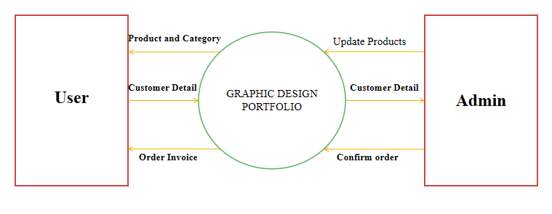

Level 1

View

Dashboard

Buy

View

User

Sale Products

Admin

**5.4.2 SYSTEM FLOW DIAGRAM**

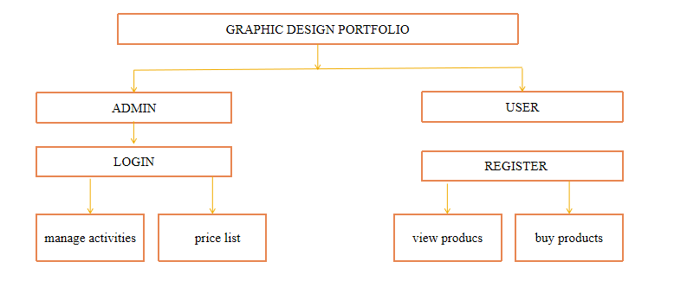

**Figure 5.4.2-System Flow Diagram**

**5.4.3 USECASE DIAGRAM**

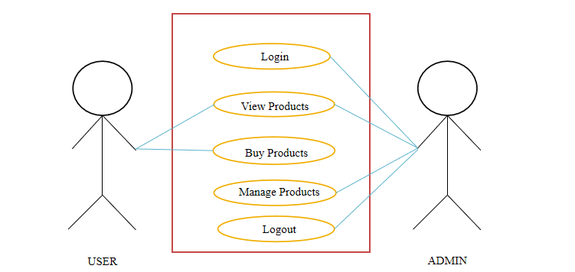

**Figure 5.4.3- Use case Diagram**

**5.4.4 ER DIAGRAM**

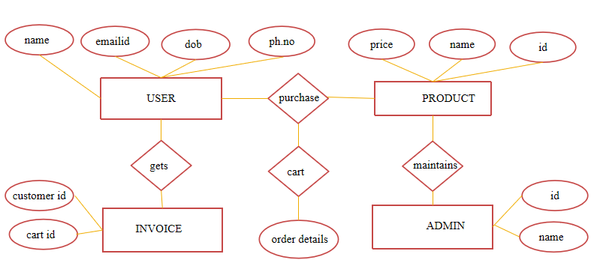

**Figure 5.4.4- ER Diagram**

**5.5 DATABASE DESIGN**

**5.5.1 ADMIN**

|  |  |  |  |  |  |
| --- | --- | --- | --- | --- | --- |
| **S.No** | Field Name | Field type | Size | Constraints | Description |
| 1. | email | Varchar | 40 | Primary Key | Admin id |
| 2. | password | Varchar | 24 | Not null | Password |

**TABLE 5.5.2**

|  |  |  |  |  |  |
| --- | --- | --- | --- | --- | --- |
| **S.No** | Field Name | Field type | Size | Constraints | Description |
| 1. | email | Varchar | 40 | Primary Key | user id |
| 2. | m_number | Varchar | 10 | Not null | User phone  number |
| 3. | type | Varchar | 15 | Not null | Design type |

**TABLE 5.5.1**

**5.5.2 USER**

**Table name :** User

**Primary key :** Email-Id

**Description :** This table is to store the user details.

**Table name :** Admin

**Primary key :** Email-Id

**Description :** This table is to store the admin details.

**CHAPTER 6**

**SYSTEM TESTING**

Testing is the process of executing a program with the intention of finding any error. A good test of course has the high probability of finding a yet undiscovered error. Successful test is the one that uncovers a yet undiscovered error.

A test is vital to the success of any system. System test makes a logical assumption that if all parts of the system are correct, then goal will be successfully achieved. The student system is subjected to a variety of tests online like responsiveness, its value, stress and security. A series of tests are performed before the system is ready for user acceptance testing.

**6.1 TESTING METHODOLOGIES**

**6.1.1 Unit Testing**

In Unit testing, test each module individually and integrate the overall system. Unit testing focuses verification effort even in the smallest unit of software development in each module. This is also known as module testing. The modules of the system is tested separately. Testing includes the process of checking Email Id and password, validating that the associate can move to respective module” sub modules. And also checking that this system is adaptable for all browsers. The modules events, coaches, rules and regulation Details, in forms and tested individually.

**6.1.2 Integration Testing**

Data can be lost across on an interface, one module have an adverse effect on the other sub-functions, when combined may not produce the desired functions. Integrated testing is the systematic testing to uncover the error within the interface.

* Admin login with the correct user name password that should be taken to respective page.
* In registration user can fill the details of the mandatory fields it should be save the request to the database with all details.
* In the app, all the forms are individually tested and integrated to begin as the running applications with the valid integrated modules.

**6.1.3 Validation Testing**

Validation testing refers to a different set of activities that ensure that the system that has been traceable to customer requirements. Data entered by the user should be validated properly and finally moved to the server. Validation testing has been applied from the login page. Phone number can be validated.

* The username and Password is wrong the system should alert to the user that

“Enter the Valid Credentials”. Passwords are also validated.

* Based on the category the sub category should be loaded.

**6.2 TEST CASE**

|  |  |  |  |  |  |
| --- | --- | --- | --- | --- | --- |
| **TEST**  **CASE ID** | **TEST CASE NAME** | **TEST CASE**  **DESC** | **TEST PRIORITY** | | **RESULT** |
| STEP | RESULT |
| 1 | Username | To verify the  user name if it  is unique | Nothing enters  and focus on  next control | An error  message shows  username is  required | Fail |
| 2 | Password | To verify the  password if it  is unique | When username & password is correct. | Accepted | Pass |
| 3 | Contact Number | For adding valid contact | Valid contact number | Uploaded  Successfully | Pass |

**CHAPTER 7**

**IMPLEMENTATION**

**STEPS TO IMPLEMENT THE SYSTEM**

The Implementation can be done by using the following steps:

**SETTING UP THE DEVELOPMENT ENVIRONMENT**

System implementation is the important stage of project when the theoretical design is tuned into practical system. After proper testing and validation, system implementation should be done. System implementation includes all those activities that take place to convert an old system to the new one. The new system may be totally new. Replacing an existing manual or automated system may be a major modification to an existing system.

There are types of Implementations:

* Implementation of computer system to replace a manual system
* Implementation of a new computer system to replace an existing system

**7.1 Implementation Procedure**

Implementation is the stage, which is crucial in the life cycle of the new system designed. The main stage in the implementation is planning, training, system testing. Implementation is converting a new or revised system into an operational one. It is the process of changing from the old system to the new one. After system is implemented, user conducts a review of the system. It is used to gather information for the maintenance of the system. The basic review method is a data collection method of questionnaire, interview etc.

**7.2 User Training**

User training cannot be provided for every user in the organization. So, in order to make it understandable and usable to every user, the screens are provided efficiently and user friendly so that even a novice user can able to work

**CHAPTER 8**

**APPENDICES**

**8.1 SOURCE CODING**

**INDEXPAGE**

**index.html**

<!DOCTYPE html>

<html lang="en" >

<head>

<meta charset="UTF-8">

<title>AN!MA_2K23</title>

<link rel='stylesheet' href='https://cdnjs.cloudflare.com/ajax/libs/twitter-bootstrap/4.1.3/css/bootstrap.min.css'><link rel="stylesheet" href="./style.css">

</head>

<body>

<!-- partial:index.partial.html -->

<div class="hero-section">

<div class="about-text hover-target">about</div>

<div class="contact-text hover-target">contact</div>

<div class="section-center">

<div class="container-fluid">

<div class="row justify-content-center">

<div class="col-12 text-center">

<h1>AN!MA</h1>

</div>

<div class="col-12 text-center mb-2">

<div class="dancing">GRAPHIC DESIGN</div>

</div>

<div class="col-12 text-center mt-4 mt-lg-5">

<p>

<span class="travel hover-target">poster</span>

<span class="wildlife hover-target">product</span>

<span class="nature hover-target">photos</span>

</p>

</div>

</div>

</div>

</div>

</div>

<div class="about-section">

<div class="about-close hover-target"></div>

<div class="section-center">

<div class="container">

<div class="row justify-content-center">

<div class="col-12 text-center">

<img src="./imgs/praveen.jpg" alt="">

</div>

<div class="col-lg-8 text-center mt-4">

<p>Hi, I'm a graphic designer with 12 months experience.I'm proud perfectionist when it come to art and design and creative enough to provide some of my best skills here.

More than 12 months experience in Graphic Design, Adobe Illustrator, Adobe Photoshop, Branding, Corporate Identity Development, Creative Ideas, Planning, Graphic Design, Identity, Illustrations, Press/Print Publication and & Packaging etc.

100% client's satisfaction.

</p>

</div>

<div class="col-12 text-center">

<p><span>Praveen</span></p>

</div>

</div>

</div>

</div>

</div>

<div class="contact-section">

<div class="contact-close hover-target"></div>

<div class="section-center">

<div class="container">

<div class="row justify-content-center">

<div class="col-12 text-center">

<a href="#" class="hover-target">praveenkavi8825@gmail.com</a>

</div>

<div class="col-12 text-center social mt-4">

<a href="https://www.behance.net/praveenn" class="hover-target">behance</a>

<a href="https://github.com/Praveen882" class="hover-target">github</a>

<a href="https://www.linkedin.com/in/praveennagaraj/" class="hover-target">linkedin</a>

</div>

</div>

</div>

</div>

</div>

<div class="travel-section">

<div class="travel-close hover-target"></div>

<div class="container">

<div class="row justify-content-center">

<div class="col-12 text-center">

<h3>poster</h3>

</div>

<div class="col-12 mt-3 text-center">

<p><span>Poster Designs</span></p>

</div>

<div class="col-12 text-center">

<p>

<br>

photoshop<br>

canva<br>

</p>

</div>

<div class="col-md-6 col-lg-4">

<img src="./imgs/poster/poster1.JPG" alt="">

</div>

<div class="col-md-6 col-lg-4">

<img src="./imgs/poster/poster2.JPG" alt="">

</div>

<div class="col-md-6 col-lg-4">

<img src="./imgs/poster/poster3.jpeg" alt="">

</div>

<div class="col-md-6 col-lg-4">

<img src="./imgs/poster/poster4.JPG" alt="">

</div>

<div class="col-md-6 col-lg-4">

<img src="./imgs/poster/poster5.jpg" alt="">

</div>

<div class="col-md-6 col-lg-4">

<img src="./imgs/poster/poster6.png" alt="">

</div>

<div class="col-md-6 col-lg-4">

<img src="http://www.ivang-design.com/svg-load/portfolio/photo-p.jpg" alt="">

</div>

<div class="col-md-6 col-lg-4">

<img src="http://www.ivang-design.com/svg-load/portfolio/photo-p.jpg" alt="">

</div>

<div class="col-md-6 col-lg-4">

<img src="http://www.ivang-design.com/svg-load/portfolio/photo-p.jpg" alt="">

</div>

<div class="col-md-6 col-lg-4">

<img src="http://www.ivang-design.com/svg-load/portfolio/photo-p.jpg" alt="">

</div>

<div class="col-md-6 col-lg-4">

<img src="http://www.ivang-design.com/svg-load/portfolio/photo-p.jpg" alt="">

</div>

<div class="col-md-6 col-lg-4">

<img src="http://www.ivang-design.com/svg-load/portfolio/photo-p.jpg" alt="">

</div>

</div>

</div>

</div>

<div class="wildlife-section">

<div class="wildlife-close hover-target"></div>

<div class="container">

<div class="row justify-content-center">

<div class="col-12 text-center">

<h3>product</h3>

</div>

<div class="col-12 mt-3 text-center">

<p><span>Product Designs</span></p>

</div>

<div class="col-12 text-center">

<p>

canva<br>

smartmockups<br>

<br>

</p>

</div>

<div class="col-md-6 col-lg-4">

<img src="./imgs/mockup/mock2.jpg" alt="">

</div>

<div class="col-md-6 col-lg-4">

<img src="./imgs/mockup/mock1.jpg" alt="">

</div>

<div class="col-md-6 col-lg-4">

<img src="./imgs/mockup/mock3.jpg" alt="">

</div>

<div class="col-md-6 col-lg-4">

<img src="./imgs/mockup/mock4.jpg" alt="">

</div>

<div class="col-md-6 col-lg-4">

<img src="./imgs/mockup/mock5.jpg" alt="">

</div>

<div class="col-md-6 col-lg-4">

<img src="./imgs/mockup/mock6.jpg" alt="">

</div>

<div class="col-md-6 col-lg-4">

<img src="http://www.ivang-design.com/svg-load/portfolio/photo-p.jpg" alt="">

</div>

<div class="col-md-6 col-lg-4">

<img src="http://www.ivang-design.com/svg-load/portfolio/photo-p.jpg" alt="">

</div>

<div class="col-md-6 col-lg-4">

<img src="http://www.ivang-design.com/svg-load/portfolio/photo-p.jpg" alt="">

</div>

<div class="col-md-6 col-lg-4">

<img src="http://www.ivang-design.com/svg-load/portfolio/photo-p.jpg" alt="">

</div>

<div class="col-md-6 col-lg-4">

<img src="http://www.ivang-design.com/svg-load/portfolio/photo-p.jpg" alt="">

</div>

<div class="col-md-6 col-lg-4">

<img src="http://www.ivang-design.com/svg-load/portfolio/photo-p.jpg" alt="">

</div>

</div>

</div>

</div>

<div class="nature-section">

<div class="nature-close hover-target"></div>

<div class="container">

<div class="row justify-content-center">

<div class="col-12 text-center">

<h3>photos</h3>

</div>

<div class="col-12 mt-3 text-center">

<p><span>Photography</span></p>

</div>

<div class="col-12 text-center">

<p>

photoshop<br>

Gimp<br>

<br>

</p>

</div>

<div class="col-md-6 col-lg-4">

<img src="./imgs/photos/photo1.jpg" alt="">

</div>

<div class="col-md-6 col-lg-4">

<img src="./imgs/photos/photo2.jpg" alt="">

</div>

<div class="col-md-6 col-lg-4">

<img src="./imgs/photos/photo3.jpg" alt="">

</div>

<div class="col-md-6 col-lg-4">

<img src="./imgs/photos/photo4.jpg" alt="">

</div>

<div class="col-md-6 col-lg-4">

<img src="./imgs/photos/photo5.jpg" alt="">

</div>

<div class="col-md-6 col-lg-4">

<img src="./imgs/photos/photo6.jpg" alt="">

</div>

<div class="col-md-6 col-lg-4">

<img src="http://www.ivang-design.com/svg-load/portfolio/photo-p.jpg" alt="">

</div>

<div class="col-md-6 col-lg-4">

<img src="http://www.ivang-design.com/svg-load/portfolio/photo-p.jpg" alt="">

</div>

<div class="col-md-6 col-lg-4">

<img src="http://www.ivang-design.com/svg-load/portfolio/photo-p.jpg" alt="">

</div>

<div class="col-md-6 col-lg-4">

<img src="http://www.ivang-design.com/svg-load/portfolio/photo-p.jpg" alt="">

</div>

<div class="col-md-6 col-lg-4">

<img src="http://www.ivang-design.com/svg-load/portfolio/photo-p.jpg" alt="">

</div>

<div class="col-md-6 col-lg-4">

<img src="http://www.ivang-design.com/svg-load/portfolio/photo-p.jpg" alt="">

</div>

</div>

</div>

</div>

<div class='cursor' id="cursor"></div>

<div class='cursor2' id="cursor2"></div>

<div class='cursor3' id="cursor3"></div>

<!-- Link to page

================================================== -->

<a href="https://front.codes/" class="link-to-portfolio hover-target" target=”_blank”></a>

<!-- partial -->

<script src='https://cdnjs.cloudflare.com/ajax/libs/jquery/3.3.1/jquery.min.js'></script><script src="./script.js"></script>

</body>

</html>

**Style.css**

@import url('https://fonts.googleapis.com/css?family=Poppins:100,100i,200,200i,300,300i,400,400i,500,500i,600,600i,700,700i,800,800i,900,900i');

@import url('https://fonts.googleapis.com/css?family=Dancing+Script:400,700');

body{

font-family: 'Poppins', sans-serif;

font-weight: 300;

font-size: 15px;

line-height: 1.6;

color: #fff;

background-color: #1f2029;

overflow: hidden;

height: 100vh;

-webkit-transition: all 300ms linear;

transition: all 300ms linear;

perspective: 800px;

}

a {

cursor: pointer;

}

a:hover {

text-decoration: none;

}

::selection {

color: #c4c3ca;

background-color: #000;

}

::-moz-selection {

color: #c4c3ca;

background-color: #000;

}

/* #Cursor

================================================== */

.cursor,

.cursor2,

.cursor3{

position: fixed;

border-radius: 50%;

transform: translateX(-50%) translateY(-50%);

pointer-events: none;

left: -100px;

top: 50%;

mix-blend-mode: difference;

-webkit-transition: all 300ms linear;

transition: all 300ms linear;

}

.cursor{

background-color: #fff;

height: 0;

width: 0;

z-index: 99999;

}

.cursor2,.cursor3{

height: 36px;

width: 36px;

z-index:99998;

-webkit-transition:all 0.3s ease-out;

transition:all 0.3s ease-out

}

.cursor2.hover,

.cursor3.hover{

-webkit-transform:scale(2) translateX(-25%) translateY(-25%);

transform:scale(2) translateX(-25%) translateY(-25%);

border:none

}

.cursor2{

border: 2px solid #fff;

}

.cursor2.hover{

background: rgba(255,255,255,1);

border-color: transparent;

}

@media screen and (max-width: 1200px){

.cursor,.cursor2,.cursor3{

display: none

}

}

/* #Primary style

================================================== */

.hero-section {

position: relative;

width: 100%;

display: block;

overflow: hidden;

height: 100vh;

background-image: url('http://www.ivang-design.com/svg-load/portfolio/photo.jpg');

background-size: cover;

background-position: center;

transform: scale(1) rotateX(0);

box-shadow: 0 0 40px rgba(0,0,0,0.2);

-webkit-transition: all 300ms linear;

transition: all 300ms linear;

-webkit-transition-delay: 400ms;

transition-delay: 400ms;

transform-origin: center top;

}

.hero-section h1{

color: #fff;

font-size: 5vw;

line-height: 1;

font-weight: 900;

}

.hero-section .dancing{

font-family: 'Dancing Script', cursive;

letter-spacing: 1px;

color: #866BAF;

font-size: 26px;

line-height: 1;

font-weight: 700;

}

@media screen and (max-width: 580px){

.hero-section .dancing{

font-size: 18px;

}

}

.hero-section p{

font-size: 15px;

line-height: 20px;

font-weight: 500;

color: #fff;

letter-spacing: 1px;

}

.hero-section p span{

margin-left: 15px;

margin-right: 15px;

position: relative;

display: inline-block;

cursor: pointer;

padding-bottom: 35px;

}

.hero-section p span:before {

position: absolute;

content: '';

bottom: 10px;

left: 50%;

height: 30px;

width: 30px;

margin-left: -15px;

z-index: -1;

background-repeat: no-repeat;

background-position: center;

background-size: 30px 30px;

background-image: url('http://www.ivang-design.com/svg-load/portfolio/down.svg');

opacity: 0.2;

-webkit-transition: all 200ms linear;

transition: all 200ms linear;

}

.hero-section p span:hover:before {

opacity: 1;

bottom: 5px;

}

body.about-on .hero-section {

transform: scale(0.75);

-webkit-transition-delay: 0ms;

transition-delay: 0ms;

}

body.contact-on .hero-section {

transform: scale(0.75);

-webkit-transition-delay: 0ms;

transition-delay: 0ms;

}

body.travel-on .hero-section {

transform: rotateX(-10deg);

-webkit-transition-delay: 0ms;

transition-delay: 0ms;

}

body.wildlife-on .hero-section {

transform: rotateX(-10deg);

-webkit-transition-delay: 0ms;

transition-delay: 0ms;

}

body.nature-on .hero-section {

transform: rotateX(-10deg);

-webkit-transition-delay: 0ms;

transition-delay: 0ms;

}

.about-text {

position: absolute;

font-size: 17px;

line-height: 20px;

font-weight: 700;

color: #fff;

letter-spacing: 2px;

top: 50%;

left: 40px;

cursor: pointer;

z-index: 2;

-webkit-writing-mode: vertical-lr;

writing-mode: vertical-lr;

transform: translateY(-50%);

-webkit-transition: all 200ms linear;

transition: all 200ms linear;

}

.about-text:before {

position: absolute;

content: '';

top: 50%;

left: -25px;

height: 30px;

width: 30px;

margin-top: -15px;

z-index: -1;

background-repeat: no-repeat;

background-position: center;

background-size: 30px 30px;

background-image: url('http://www.ivang-design.com/svg-load/portfolio/left.svg');

opacity: 0.2;

-webkit-transition: all 200ms linear;

transition: all 200ms linear;

}

.about-text:hover:before {

opacity: 1;

left: -30px;

}

.about-section {

position: fixed;

top: 0;

left: 0;

width: 100%;

display: block;

overflow: hidden;

height: 100vh;

background-color: rgba(31,32,41,1);

transform: translateX(-100%);

-webkit-transition: all 300ms linear;

transition: all 300ms linear;

z-index: 10;

}

body.about-on .about-section {

transform: translateX(0);

-webkit-transition-delay: 400ms;

transition-delay: 400ms;

}

.about-close {

position: absolute;

top: 20px;

right: 20px;

width: 30px;

display: block;

overflow: hidden;

height: 30px;

-webkit-transition: all 200ms linear;

transition: all 200ms linear;

background-repeat: no-repeat;

background-position: center;

background-size: 36px 36px;

background-image: url('http://www.ivang-design.com/svg-load/portfolio/close.svg');

cursor: pointer;

z-index: 11;

}

.about-close:hover {

transform: rotate(90deg);

}

.section-center {

position: absolute;

width: 100%;

left: 0;

top: 50%;

transform: translateY(-50%);

z-index: 1;

}

.about-section img {

width: 100px;

height: 100px;

border-radius: 4px;

display: block;

margin: 0 auto;

box-shadow: 0 0 20px rgba(0,0,0,0.15);

}

.about-section p span {

font-family: 'Dancing Script', cursive;

letter-spacing: 1px;

color: #866BAF;

font-size: 25px;

font-weight: 400;

}

.contact-text {

position: absolute;

font-size: 17px;

line-height: 20px;

font-weight: 700;

color: #fff;

letter-spacing: 2px;

top: 50%;

right: 40px;

cursor: pointer;

z-index: 2;

-webkit-writing-mode: vertical-lr;

writing-mode: vertical-lr;

transform: translateY(-50%) rotate(180deg);

-webkit-transition: all 200ms linear;

transition: all 200ms linear;

}

.contact-text:before {

position: absolute;

content: '';

top: 50%;

left: -25px;

height: 30px;

width: 30px;

margin-top: -15px;

z-index: -1;

background-repeat: no-repeat;

background-position: center;

background-size: 30px 30px;

background-image: url('http://www.ivang-design.com/svg-load/portfolio/left.svg');

opacity: 0.2;

-webkit-transition: all 200ms linear;

transition: all 200ms linear;

}

.contact-text:hover:before {

opacity: 1;

left: -30px;

}

.contact-section {

position: fixed;

top: 0;

left: 0;

width: 100%;

display: block;

overflow: hidden;

height: 100vh;

background-color: rgba(31,32,41,1);

transform: translateX(100%);

-webkit-transition: all 300ms linear;

transition: all 300ms linear;

z-index: 10;

}

body.contact-on .contact-section {

transform: translateX(0);

-webkit-transition-delay: 400ms;

transition-delay: 400ms;

}

.contact-close {

position: absolute;

top: 20px;

right: 20px;

width: 30px;

display: block;

overflow: hidden;

height: 30px;

-webkit-transition: all 200ms linear;

transition: all 200ms linear;

background-repeat: no-repeat;

background-position: center;

background-size: 36px 36px;

background-image: url('http://www.ivang-design.com/svg-load/portfolio/close.svg');

cursor: pointer;

z-index: 11;

}

.contact-close:hover {

transform: rotate(90deg);

}

.contact-section a{

margin: 0 auto;

font-size: 32px;

font-weight: 900;

letter-spacing: 1px;

color: #fff;

display: inline-block;

}

.contact-section .social a{

margin-left: 8px;

margin-right: 8px;

font-size: 15px;

font-weight: 600;

letter-spacing: 1px;

color: #866BAF;

}

@media screen and (max-width: 580px){

.contact-section a{

font-size: 17px;

}

.contact-section .social a{

margin-left: 3px;

margin-right: 3px;

font-size: 13px;

letter-spacing: 0;

}

}

.travel-section,

.wildlife-section,

.nature-section {

position: fixed;

top: 100%;

left: 0;

padding: 100px 0;

width: 100%;

height: 100vh;

display: block;

overflow-x: hidden;

overflow-y: auto;

background-color: rgba(31,32,41,1);

-webkit-transition: all 300ms linear;

transition: all 300ms linear;

z-index: 10;

}

.travel-close,

.wildlife-close,

.nature-close {

position: absolute;

top: 20px;

right: 20px;

width: 30px;

display: block;

overflow: hidden;

height: 30px;

-webkit-transition: all 200ms linear;

transition: all 200ms linear;

background-repeat: no-repeat;

background-position: center;

background-size: 36px 36px;

background-image: url('http://www.ivang-design.com/svg-load/portfolio/close.svg');

cursor: pointer;

z-index: 11;

}

.travel-close:hover,

.wildlife-close:hover,

.nature-close:hover {

transform: rotate(90deg);

}

body.travel-on .travel-section {

top: 0;

-webkit-transition-delay: 400ms;

transition-delay: 400ms;

}

body.wildlife-on .wildlife-section {

top: 0;

-webkit-transition-delay: 400ms;

transition-delay: 400ms;

}

body.nature-on .nature-section {

top: 0;

-webkit-transition-delay: 400ms;

transition-delay: 400ms;

}

.travel-section img,

.wildlife-section img,

.nature-section img {

margin-top: 30px;

width: 100%;

height: auto;

display: block;

border-radius: 4px;

box-shadow: 0 0 20px rgba(0,0,0,0.4);

}

.travel-section h3,

.wildlife-section h3,

.nature-section h3 {

font-size: 44px;

line-height: 1.3;

font-weight: 700;

letter-spacing: 1px;

color: #fff;

}

.travel-section p,

.wildlife-section p,

.nature-section p {

font-size: 14px;

line-height: 1.7;

letter-spacing: 1px;

}

.travel-section p span,

.wildlife-section p span,

.nature-section p span {

font-size: 20px;

line-height: 1.3;

font-weight: 700;

color: #866BAF;

}

/* #Link to page

================================================== */

.link-to-portfolio {

position: fixed;

bottom: 30px;

right: 30px;

z-index: 200;

cursor: pointer;

width: 50px;

height: 50px;

text-align: center;

border-radius: 3px;

background-position: center center;

background-size: 65%;

background-repeat: no-repeat;

background-image: url('https://assets.codepen.io/1462889/fcy.png');

box-shadow: 0 0 0 2px rgba(255,255,255,.1);

transition: opacity .2s, border-radius .2s, box-shadow .2s;

transition-timing-function: ease-out;

}

.link-to-portfolio:hover {

opacity: 0.8;

border-radius: 50%;

box-shadow: 0 0 0 20px rgba(255,255,255,.1);

}

**Script.js**

(function($) { "use strict";

//Page cursors

document.getElementsByTagName("body")[0].addEventListener("mousemove", function(n) {

t.style.left = n.clientX + "px",

t.style.top = n.clientY + "px",

e.style.left = n.clientX + "px",

e.style.top = n.clientY + "px",

i.style.left = n.clientX + "px",

i.style.top = n.clientY + "px"

});

var t = document.getElementById("cursor"),

e = document.getElementById("cursor2"),

i = document.getElementById("cursor3");

function n(t) {

e.classList.add("hover"), i.classList.add("hover")

}

function s(t) {

e.classList.remove("hover"), i.classList.remove("hover")

}

s();

for (var r = document.querySelectorAll(".hover-target"), a = r.length - 1; a >= 0; a--) {

o(r[a])

}

function o(t) {

t.addEventListener("mouseover", n), t.addEventListener("mouseout", s)

}

//About page

$(".about-text").on('click', function () {

$("body").addClass("about-on");

});

$(".about-close").on('click', function () {

$("body").removeClass("about-on");

});

//Contact page

$(".contact-text").on('click', function () {

$("body").addClass("contact-on");

});

$(".contact-close").on('click', function () {

$("body").removeClass("contact-on");

});

//Travel portfolio page

$(".travel").on('click', function () {

$("body").addClass("travel-on");

});

$(".travel-close").on('click', function () {

$("body").removeClass("travel-on");

});

//Wildlife portfolio page

$(".wildlife").on('click', function () {

$("body").addClass("wildlife-on");

});

$(".wildlife-close").on('click', function () {

$("body").removeClass("wildlife-on");

});

//Nature portfolio page

$(".nature").on('click', function () {

$("body").addClass("nature-on");

});

$(".nature-close").on('click', function () {

$("body").removeClass("nature-on");

});

})(jQuery);

**8.2 SCREENSHOTS**

**HOMEPAGE**



**ABOUT**



**SERVICES**

**POSTER DESIGN**



**PRODUCT DESIGN**

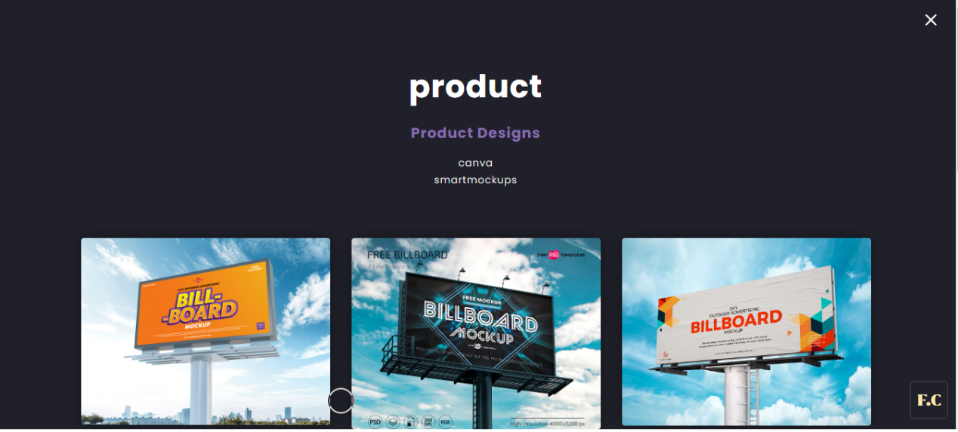

**PHOTOGRAPHY**

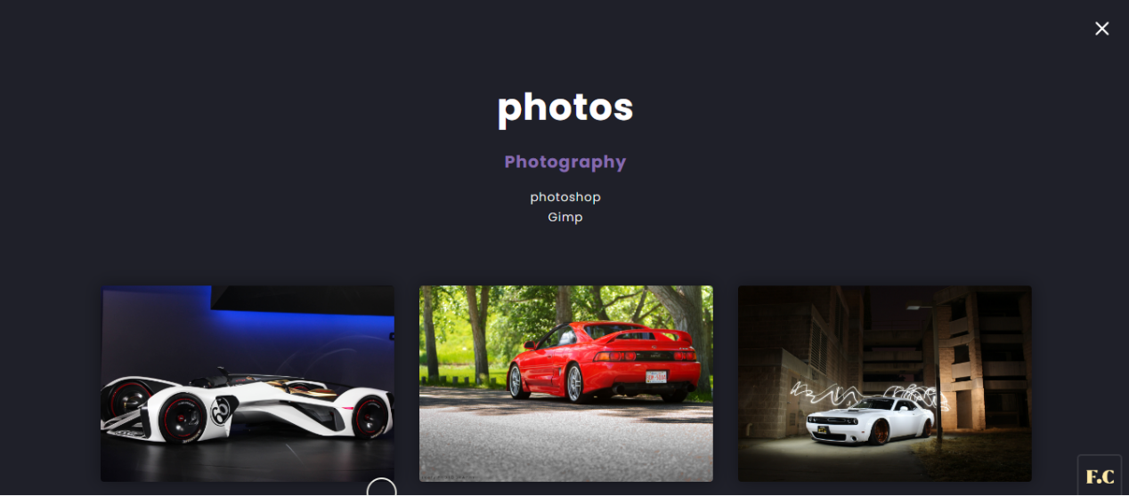

**CONTACT PAGE**

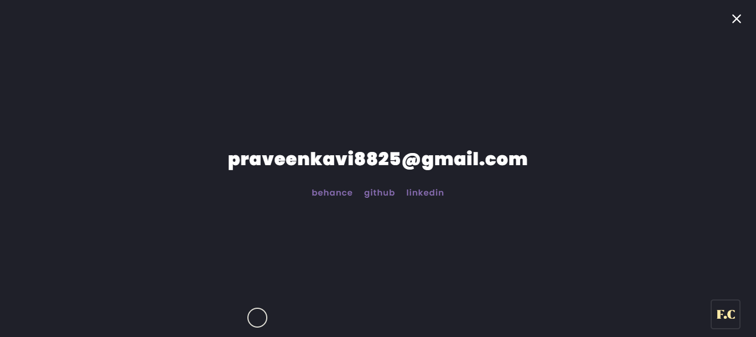

**SIGNIN / SIGNUP**

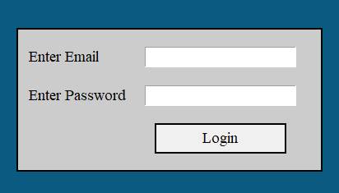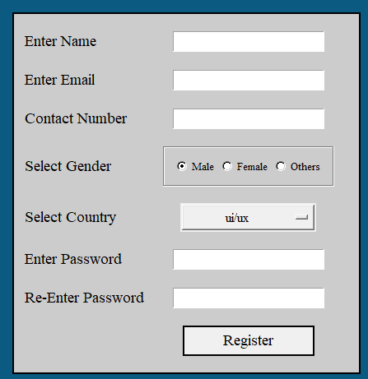

**DATABASE**

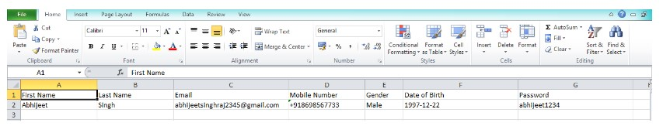

**CHAPTER 9**

**CONCLUSION AND FUTURE ENHANCEMENT**

**9.1 CONCLUSION**

To conclude, “Graphic Design Portfolio” is a simple web based application basically suitable stack holder. It has very basic items which are used for the better usage of their user. It is very successful in making this application were we can view user and view and register activity in that web page.

This entire application is documented and can be easily understood by the users. The forms are very user friendly and also easy to handle even by the beginners with very little effort and guidance.

**9.2 FUTURE ENHANCEMENTS**

Since the project was started with very little knowledge about the Graphic Design Portfolio. This web application can be converted to the mobile app, so that it becomes easier for users to buy designs. It will also easier for admin to view their client registration list any time they want. It can be extended further by adding additional functionalities like:

* Security and data privacy,
* Personalized experience,
* Evolution of technology and safety,
* Virtual realities.

**CHAPTER 10**

**REFERENCES**

1.’David DuRocher’, HTML & CSS, Quick Start Guide,

2.’Cooper alvin’, HTML AND CSS,

3.’Thomas A.powell’,’Fritz Schneider’, JavaScript, Third edition.

**WEBSITES**

1. <https://www.w3schools.com/>
2. <https://codepen.io/>
3. <https://www.guru99.com/>
4. <https://www.freecodecamp.org/>
5. <https://alison.com/>
6. <https://html.com/>
7. <https://javascript.info/>
8. <https://animate.style/>
9. <https://www.javatpoint.com/css-tutorial>
10. <https://github.com/>